# **Download, Install and configure Packer**

## -To download, Install and configure packer.

To download packer by using the following link:

- (<https://www.packer.io/downloads>)

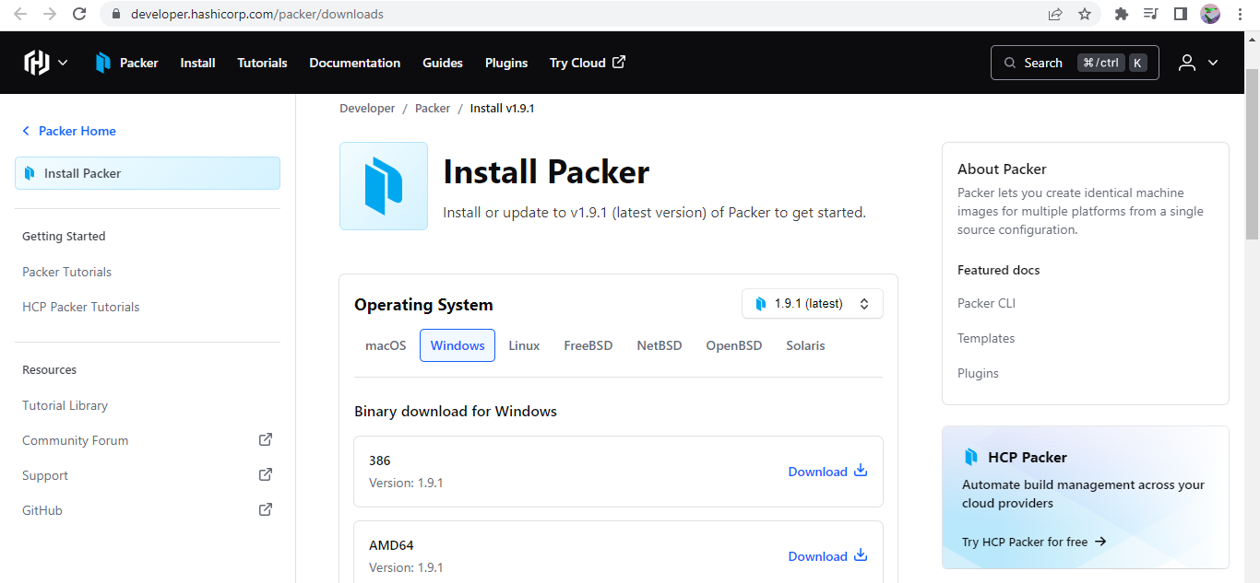

## -To create a folder packer in c :> program files:

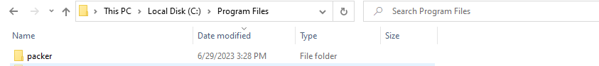

## -Packer.exe file extract in c :> program files/packer folder:

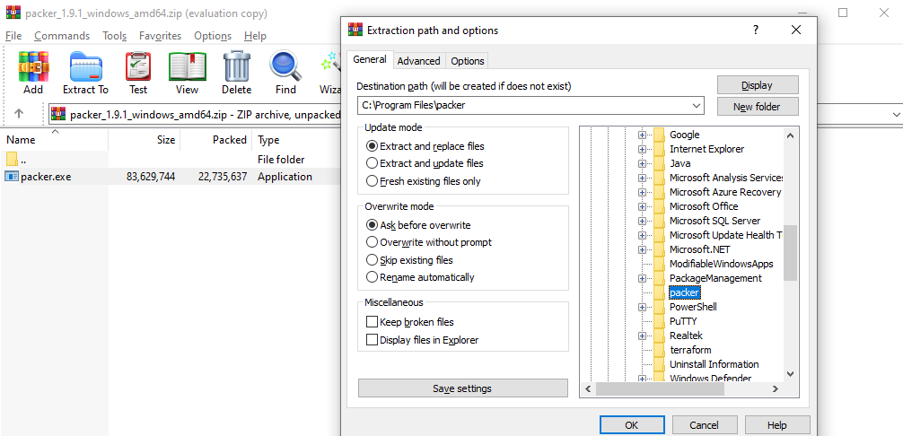

## -To check the executable file in c :> program files>packer:

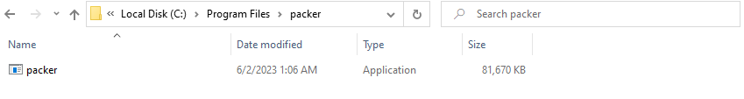

## -To add the environment variable: Path- C:\Program Files\packer

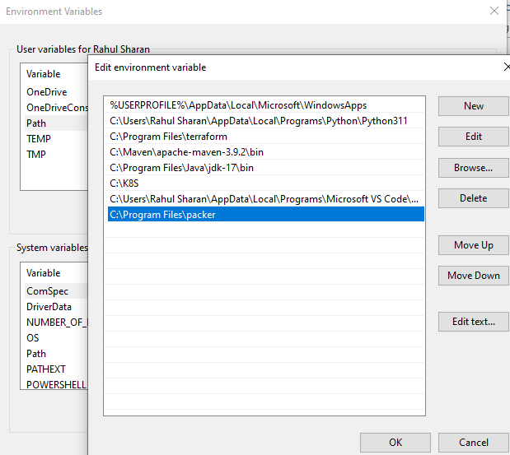

## -Open command prompt and check the packer version by using the following the command:

>packer --version

